DAY 9 TASK 3
First prompt used to create the invoices directly:
Create ONLY the 20 labelled invoices. Read only samples/invoices/Invoice_001.txt and data/po_list.json. Write 20 files to eval/invoices/ (14 valid matching a PO, 6 with one defect each: unit price, missing PO, total not sum, 14-char GSTIN, due before invoice date, vendor mismatch) and eval/labels.json with the expected outcome and reason for each. Do not call any model and do not change agent/ or mcp_server/. Reply in 3 lines or less.
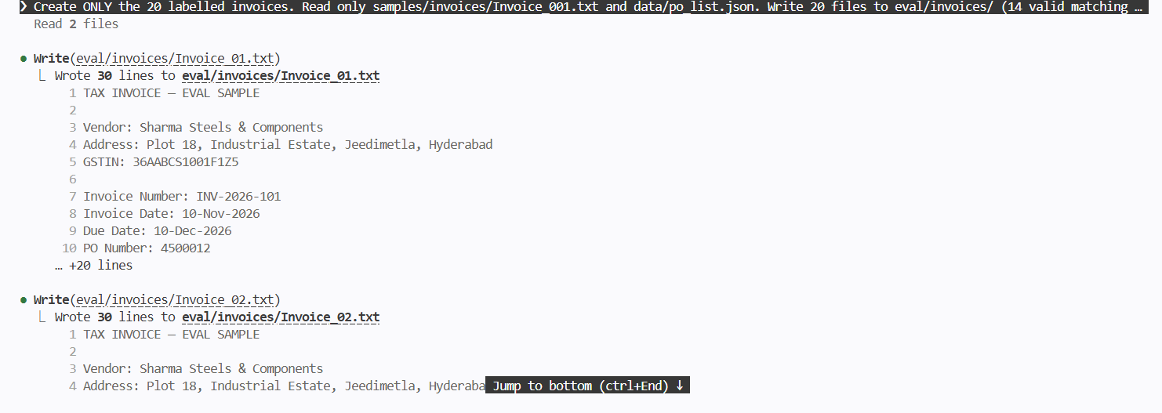
Checked with the input tokens and all for checking them, accuracy,cost and time in HAIKU 5.5:
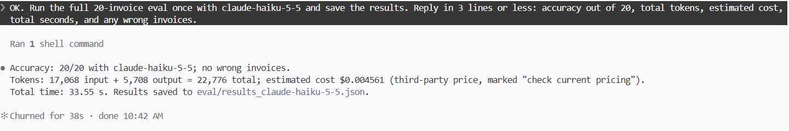
Checked with the input tokens and all for checking them, accuracy, cost and time in SONET 5.5:
The model I chose:
I chose Haiku 5.5 as the model for this project.
Both Haiku 5.5 and Sonnet 5.5 got 20 out of 20 invoices right, so accuracy did not separate them. With equal accuracy, the cheaper and faster model is the better production choice, and Haiku 5.5 is the lighter model. The validator also re-checks every number in code, so a smaller model is safe for extraction.

